# **Bài tập xPath Buổi 10**

**(Học viên áp dụng các hàm, cấu trúc xPath đã học trong buổi 10)**

***Bài 1: vào trang*** [***https://alada.vn/tai-khoan/dang-ky.html***](https://alada.vn/tai-khoan/dang-ky.html)

1. ***Tìm xPath các element trên trang đăng ký và fill vào bảng sau***

|  |  |  |
| --- | --- | --- |
| *Tên element (tự đặt tên)* | *xPath* | *Note* |
| *txtHoVaTen* | *//input[@id='txtFirstname']* | [*https://imgur.com/o2d4Cdk*](https://imgur.com/o2d4Cdk) |
| *txtEmail* | *//input[@id='txtEmail']* | [*https://imgur.com/YtYghem*](https://imgur.com/YtYghem) |
| *txtNhapLaiEmail* | *//input[@id='txtCEmail']* | [*https://imgur.com/awaLGMc*](https://imgur.com/awaLGMc) |
| *txtMatKhau* | *//input[@id='txtPassword']* | [*https://imgur.com/pss5ZnS*](https://imgur.com/pss5ZnS) |
| *txtNhapLaiMatKhau* | *//input[@id='txtCPassword']* | [*https://imgur.com/D6LdDXZ*](https://imgur.com/D6LdDXZ) |
| *txtDienThoai* | *//input[@id='txtPhone']* | [*https://imgur.com/u93AKzL*](https://imgur.com/u93AKzL) |
| *cbxDongY* | *//input[@id='chkRight']* | [*https://imgur.com/3hFWmLz*](https://imgur.com/3hFWmLz) |
| *linkChinhSach* | *//a[text()='chính sách']* | [*https://imgur.com/oK7IHCU*](https://imgur.com/oK7IHCU) |
| *linkThoaThuan* | *//a[contains(text(),'thỏa thuận')]* | [*https://imgur.com/OPL6kxq*](https://imgur.com/OPL6kxq) |
| *btnDangKy* | *//button[text()='ĐĂNG KÝ' and @type='submit']* | [*https://imgur.com/zWvuF9r*](https://imgur.com/zWvuF9r) |

1. ***Vào trang chỉnh sửa thông tin***

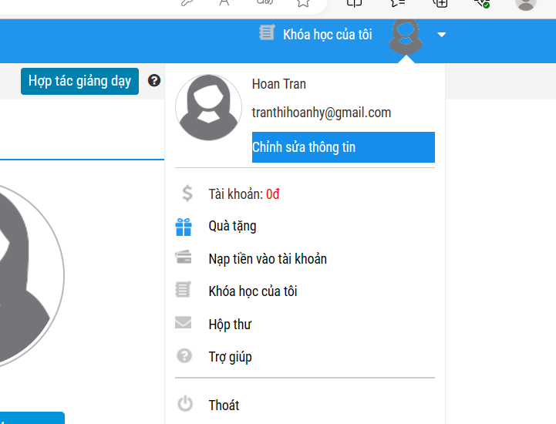***Sau đó tìm xPath các element trên trang Thông tin cá nhân và fill vào bảng sau***

|  |  |  |
| --- | --- | --- |
| ***Tên element (tự đặt tên)*** | ***xPath*** | ***Note*** |
| *txtHo* | *//input[@id='member_lastname']* | [*https://imgur.com/wpdVGAg*](https://imgur.com/wpdVGAg) |
| *txtTen* | *//input[@id='member_firstname']* | [*https://imgur.com/43NRHqs*](https://imgur.com/43NRHqs) |
| *checkGioiTinh* | *//input[@name='member_gender[]']* | [*https://imgur.com/0gYrgGe*](https://imgur.com/0gYrgGe) |
| *dateNgaySinh* | *//input[@id='member_birthday']* | [*https://imgur.com/ECGUnPP*](https://imgur.com/ECGUnPP) |
| *dropdownTinhTP* | *//select[@id='txtCity']* | [*https://imgur.com/Q6t5Ft6*](https://imgur.com/Q6t5Ft6) |
| *txtDienThoai* | *//input[@id='member_tel']* | [*https://imgur.com/gRa8Woe*](https://imgur.com/gRa8Woe) |
| *txtDiaChi* | *//input[@id='member_address']* | [*https://imgur.com/ZBF7yUg*](https://imgur.com/ZBF7yUg) |
| *txtCongTy* | *//input[@id='member_company']* | [*https://imgur.com/NUsAgpT*](https://imgur.com/NUsAgpT) |
| *btnLuuThongTin* | *//button[text()='Lưu thông tin']* | [*https://imgur.com/f4SECMb*](https://imgur.com/f4SECMb) |
| *txtTenDangNhap* | *//input[@readonly='readonly']* | [*https://imgur.com/KOrEjTe*](https://imgur.com/KOrEjTe) |
| *txtMatKhauHienTai* | *//input[@id='txtpassword']* | [*https://imgur.com/N2DCLpG*](https://imgur.com/N2DCLpG) |
| *txtMatKhauMoi* | *//input[@id='txtnewpass']* | [*https://imgur.com/EOv4CHZ*](https://imgur.com/EOv4CHZ) |
| *txtNhapLaiMatKhauMoi* | *//input[@id='txtrenewpass']* | [*https://imgur.com/VVrTYld*](https://imgur.com/VVrTYld) |
| *btnLuuMatKhauMoi* | *//button[text()='Lưu mật khẩu mới']* | [*https://imgur.com/pUvZVXY*](https://imgur.com/pUvZVXY) |
| *btnThayAvatar* | *//button[text()='Thay đổi avatar']* | [*https://imgur.com/O4hw1Is*](https://imgur.com/O4hw1Is) |

***Bài 2: vào trang***

[***https://demo.seleniumeasy.com/basic-checkbox-demo.html***](https://demo.seleniumeasy.com/basic-checkbox-demo.html)

***Ở left menu -> click vào Input form -> click vào Radio Button Demo và tìm xPath của các elements được khoanh tròn trong ảnh sau, điền xPath vào bảng.***

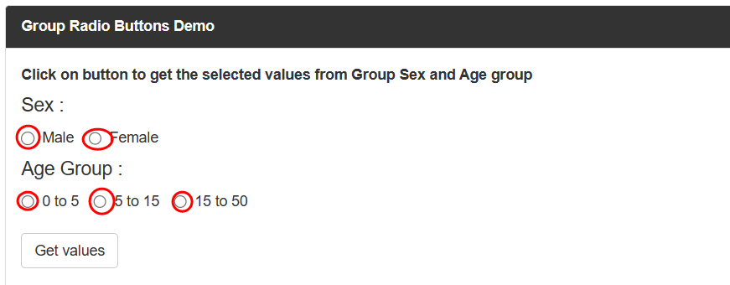

|  |  |  |
| --- | --- | --- |
| ***Tên element (tự đặt tên)*** | ***xPath*** | ***Note*** |
| *rdoMale* | *//input[@value='Male' and @name='gender']* | [*https://imgur.com/9F20Vsb*](https://imgur.com/9F20Vsb) |
| *rdoFemale* | *//input[@value='Female' and @name='gender']* | [*https://imgur.com/vd4ZViq*](https://imgur.com/vd4ZViq) |
| *rdoAge0To5* | *//input[@value='0 - 5' and @name='ageGroup']* | [*https://imgur.com/XDsmCYz*](https://imgur.com/XDsmCYz) |
| *rdoAge5To15* | *//input[@value='5 - 15' and @name='ageGroup']* | [*https://imgur.com/62cqhQa*](https://imgur.com/62cqhQa) |
| *rdoAge15To50* | *//input[@value='15 - 50' and @name='ageGroup']* | [*https://imgur.com/9pjcdWD*](https://imgur.com/9pjcdWD) |
|  |  |  |

***Bài 3: vào trang*** [***https://rise.fairsketch.com/events***](https://rise.fairsketch.com/events) ***và tìm locator của element 2 đặt tên testEvent sao cho có sự liên quan: element 2 nằm trong element 1. (Áp dụng cho việc xác nhận rằng event nào đó sau khi tạo sẽ thuộc một ngày nào đó)***

|  |  |  |
| --- | --- | --- |
| ***Tên element*** | ***xPath*** | ***Note*** |
| *testEvent* | *//td[@data-date='2024-08-13']/descendant::span/descendant::span* | [*https://imgur.com/lms1T1Y*](https://imgur.com/lms1T1Y) |

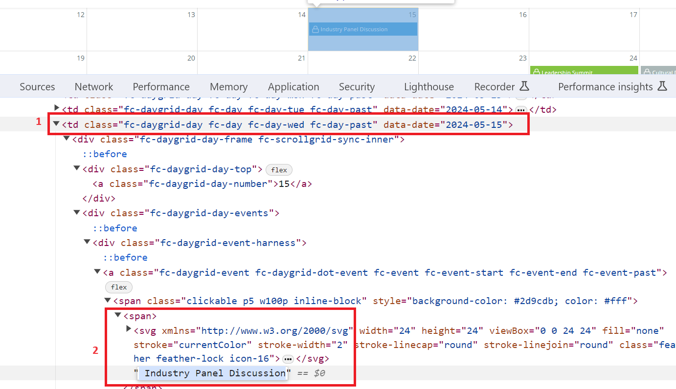

***Các bạn đẩy file lên github sau khi làm xong nhé !***